
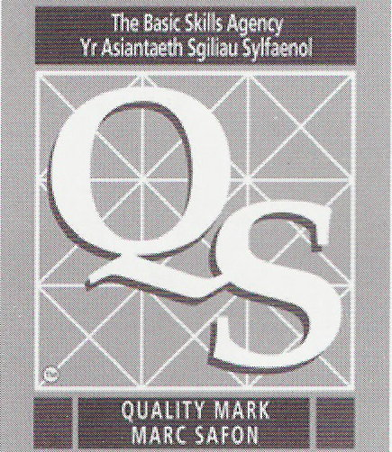
Y.G.G. GELLIONNEN
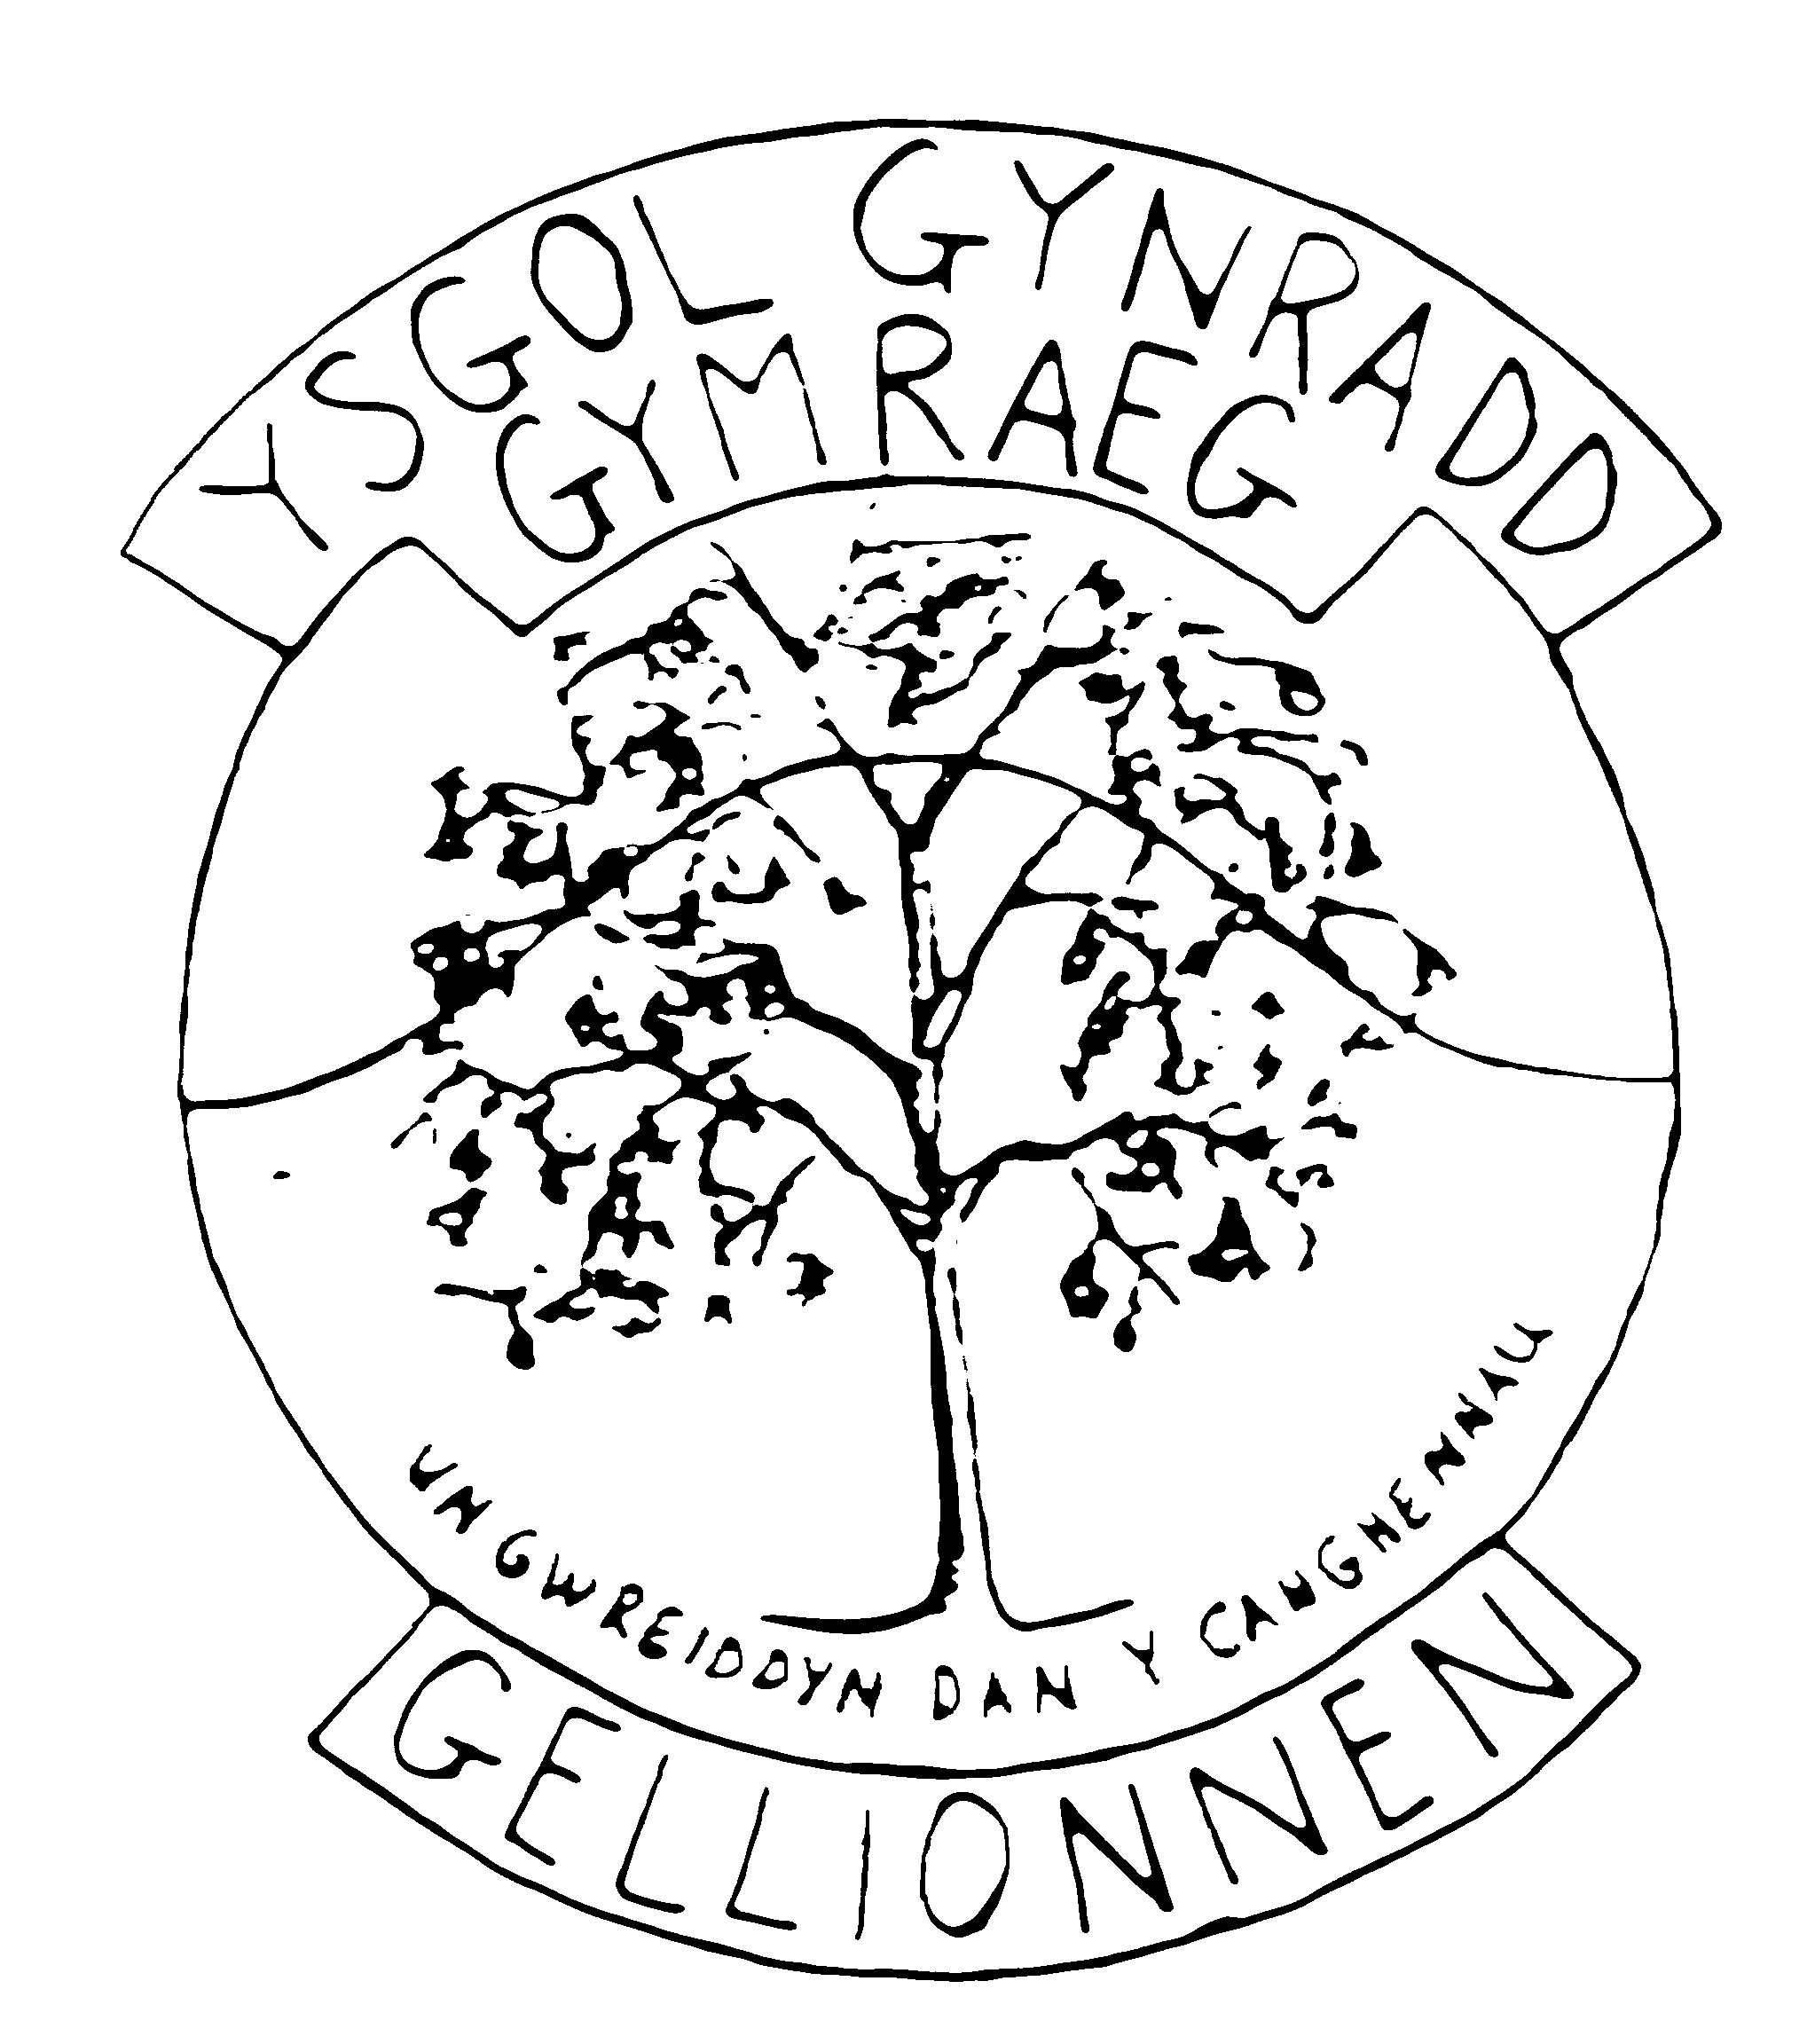

Heol Gellionnen
Clydach
Abertawe
SA6 5HE

Ffôn:/Tel: 01792 845489

Pennaeth:/Headteacher: Mrs. Delyth Mainwaring BSc (Anrh) MSc
Ffacs:/Fax: 01792 844221
E-Bost/E-mail YGG.Gellionnen@swansea-edunet.gov.uk
Gwefan/website:www.ygggellionnen.weebly.com

DIWRNOD COCH/GWYN A GWYRDD
RED/WHITE AND GREEN DAY
GWENER/FRIDAY 23/05/14

Byddwn yn gwisgo dillad Coch/Gwyn/Gwyrdd i’r ysgol ar Ddydd Gwener 23ain o Fai i ddathlu wythnos Eisteddfod yr Urdd yn ystod hanner tymor. Gofynwn yn garedig i bob plentyn ddod a £1 i’r ysgol ar y diwrnod yma. Diolch.

We will be wearing Red/White/Green clothes to school on Friday 23rd May to celebrate the Urdd Eisteddfod week during the half term holiday. We kindly ask that the children bring £1 each to school on this day. Thank you.

Y.G.G. GELLIONNEN

Heol Gellionnen
Clydach
Abertawe
SA6 5HE

Ffôn:/Tel: 01792 845489

Pennaeth:/Headteacher: Mrs. Delyth Mainwaring BSc (Anrh) MSc
Ffacs:/Fax: 01792 844221
E-Bost/E-mail YGG.Gellionnen@swansea-edunet.gov.uk
Gwefan/website:www.ygggellionnen.weebly.com

DIWRNOD COCH/GWYN A GWYRDD
RED/WHITE AND GREEN DAY
GWENER/FRIDAY 23/05/14

Byddwn yn gwisgo dillad Coch/Gwyn/Gwyrdd i’r ysgol ar Ddydd Gwener 23ain o Fai i ddathlu wythnos Eisteddfod yr Urdd yn ystod hanner tymor. Gofynwn yn garedig i bob plentyn ddod a £1 i’r ysgol ar y diwrnod yma. Diolch.

We will be wearing Red/White/Green clothes to school on Friday 23rd May to celebrate the Urdd Eisteddfod week during the half term holiday. We kindly ask that the children bring £1 each to school on this day. Thank you.

